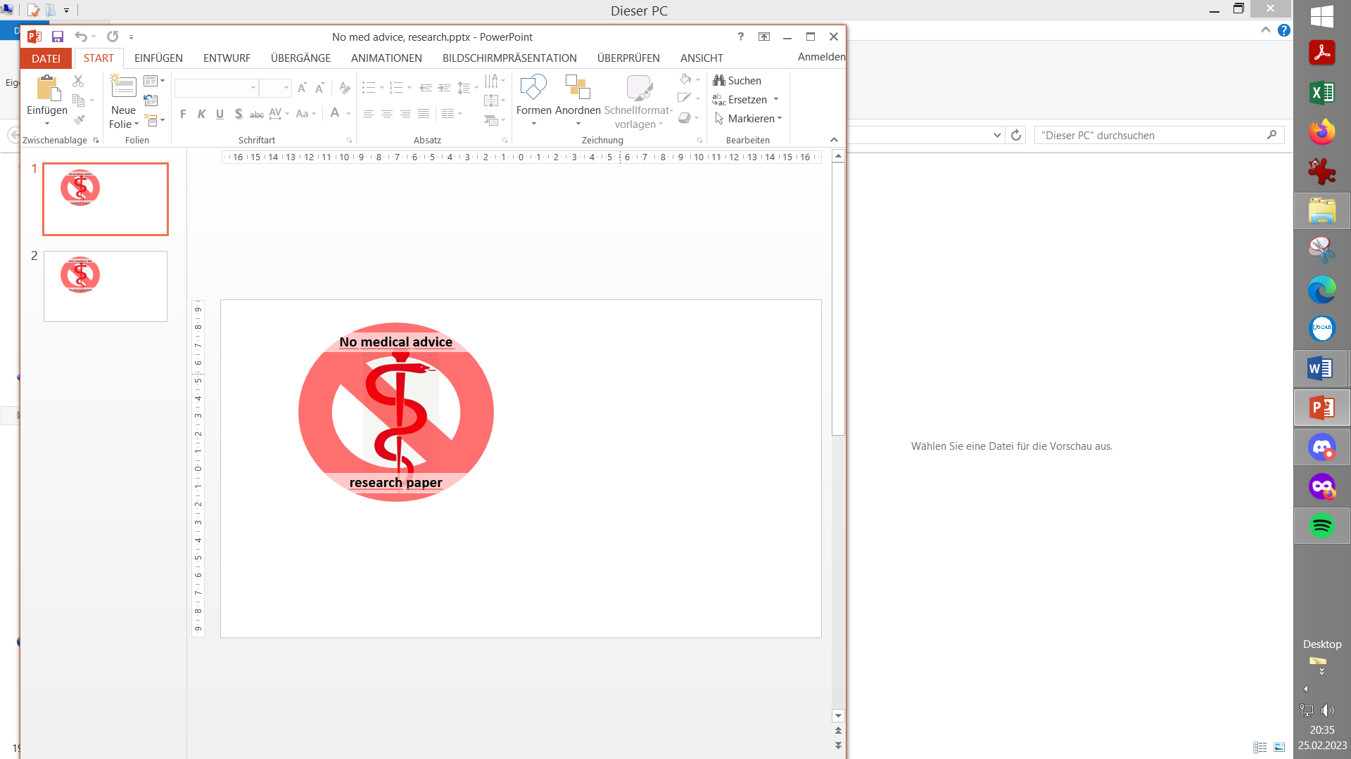
Uses, and misuses, of Automations in AAPS
Contribution to the discussion among DIY loopers
The authors assume no liability B.Loeff (Oct.25 publ. in AAPS Users FB) V.1.0

Certain Automations are likely to negatively affect the functioning of your AAPS loop
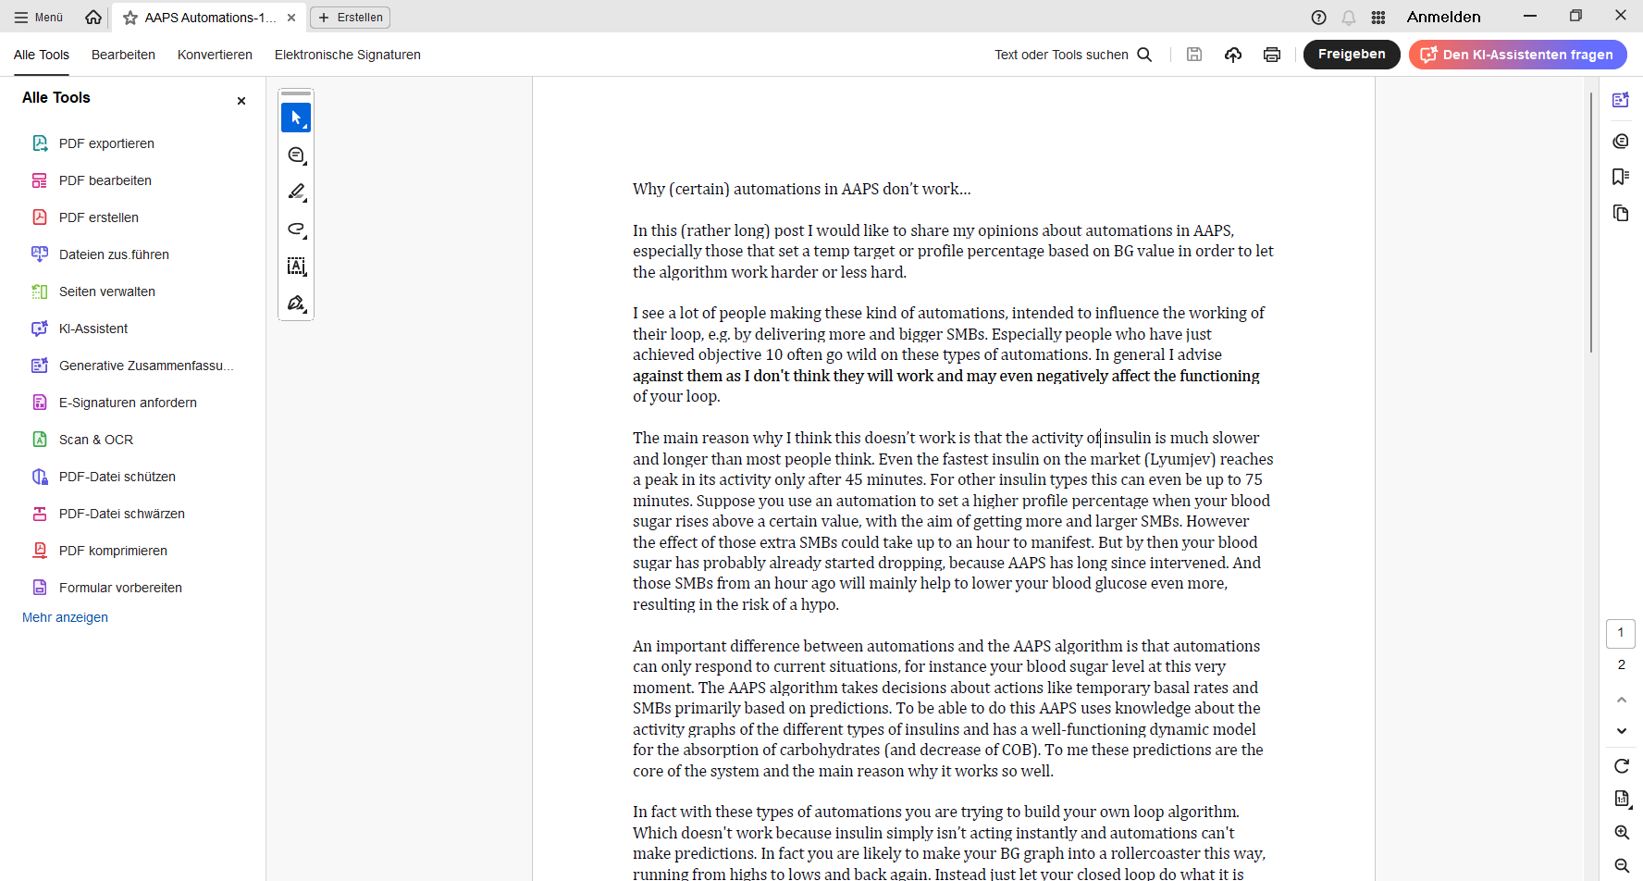
The AAPS algorithm is in principle superior to what you might try via Automation

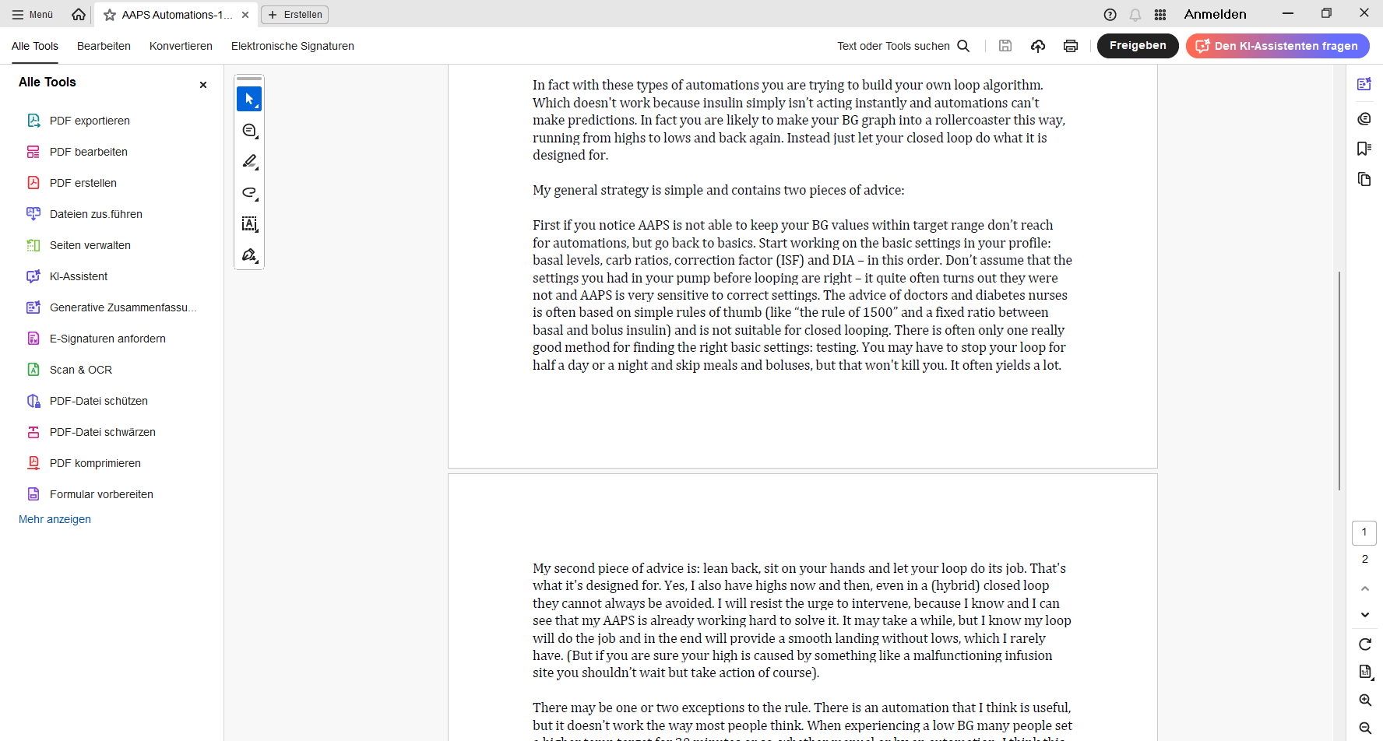

Advice to tune the AAPS loop without making use of Automations
Note: There is a reason why we “unlock” Automations late in the AAPS Objectives, after supposedly everybody has tuned their loop well.


Examples for beneficial Automations
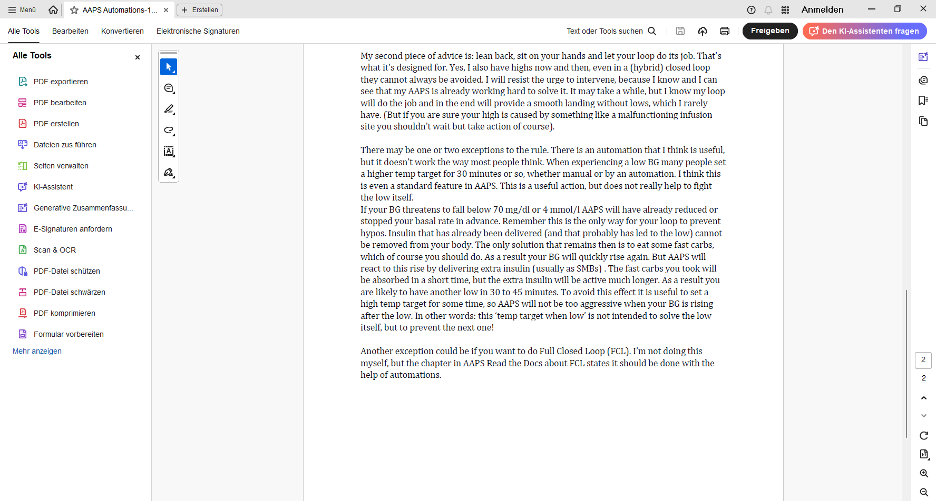
We can generalize a bit from this given example and say: As long as you let the loop work its usual way (based on predictions etc.) it can be helpful to use Automations to modulate aggressiveness (e.g. by setting temp. targets, by temp. modifying ISF). Carefully analyze your data - AFTER YOU DID A DECENT FIRST TUNING WITHOUT RESORTING TO AUTOMATIONS - to eventually see sets of Conditions where it might make sense to temporarily change aggressiveness. More see: https://androidaps.readthedocs.io/en/latest/DailyLifeWithAaps/Automations.html#how-automation-can-help

In case you can not identify a reliable automatic trigger Condition, you can make it a “User Action” Automation => A grey button on the bottom of your AAPS main screen (for instance “Snack after sports”) lets you select a pre-defined temp. mode with different aggressiveness, at your easy disposal whenever you know the relevant Condition (as reflected in the name you give your Automation, and on that grey button) is present. For more see https://androidaps.readthedocs.io/en/latest/AdvancedOptions/FullClosedLoop.html#fcl-s-automation-templates + examples given in Github/Bernie4375/FCL eBook, Case Studies 5.2 and 6.2 (these only work with autoISF dev version of AAPS, though)
Important: Always limit the duration for any Automations as much as you can. 3 Reasons for this: 1) You basically want to run your tuned loop. 2) Episodes with softer or stronger aggressiveness should be anchored on Conditions you see in your data. As long as these Conditions persist, the Automation would kick in again (=automatically prolong). 3) Any other Automation, even if Conditions arose that make it very desirable, is blocked while your prior Automation has not stopped. And when it has stopped, AAPS goes through all your Automations (those ticked as active=waiting to eventually kick in) strictly in the sequence of your list. So, make sure you list all your Automations in a reasonable order, so important ones are not shut out by less important ones! https://androidaps.readthedocs.io/en/latest/DailyLifeWithAaps/Automations.html#the-order-of-the-automations-in-the-list-matters
Beyond changing aggressiveness, Actions triggered by Automations might also set temporary boundaries
(insert added by Bernie)

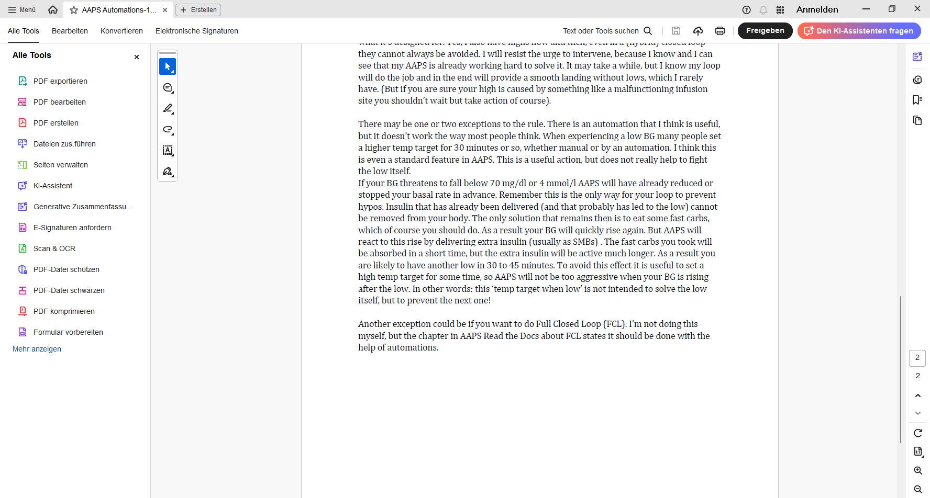https://androidaps.readthedocs.io/en/latest/AdvancedOptions/FullClosedLoop.html#meal-detection-your-automations-for-boosting

Alternatives to AAPS Automations
For advanced users, and for users of other oref loops (Trio, iAPS), there are other possibilities to automate tasks using IFTTT, a third party Android app called Automate, or so-called Middleware.

